**<Use Case Number 1> <AMS/Notify>**

|  |  |  |  |
| --- | --- | --- | --- |
| Date | Version | Updated by | Comments |
| 8/28/2019 | 1 | Rakesh Wani | FOBPM AMS/Notify SOAP Request |

Contents

1. Detailed Issue Description 1

2. Sample Tickets 1

3. Access 1

4. Steps 1

5. Proactive Solution Approach (if applicable) 2

6. Ticket Closure Process 2

# Detailed Issue Description

User request to send AMS/Notify Request Manually

**Root Cause -**

As data not sync between FOBPM, Canopi and SMP

Average ticket counts: 5 Ticket Per Months.

Average Time – 2 days (Depends on no of USID)

# Sample Tickets

TT:# 000000267452819

PROB_DESC: ActivateMetrocellService did not complete for some reason. Please resubmit.

TT:# 000000264318808

PROB_DESC: Please resend AMS for the attached projects

|  |  |  |  |  |
| --- | --- | --- | --- | --- |
| USID | PO | ECGI | CSGID | DEVID |
| 269125 | 26621273 | 310410557ff88fef4 | 120731641 | LBALLUSRC161700061 |
| 269109 | 26618782 | 31041020fff87b8f0 | 120000473 | LBALLUSRC163400261 |
| 269162 | 26625067 | 310410887ff6ebbf4 | 120000532 | LBALLUSRC175100018 |
| 267594 | 26351921 | 3104108bfaf70aff6 | 120731646 | LBALLUSRC182500383 |
| 268740 | 26566420 | 3104106afef70cff4 | 120731626 | LBALLUSRC184900294 |
| 269148 | 26622613 | 310410857ff6ebaf6 | 120731676 | LBALLUSRC184900398 |

# Access

|  |  |
| --- | --- |
| Application |  |
| Database | Prod DB: FLPI555-VIP.FFDC.SBC.COM  PORT - 1521  SID - P1CNP1D11  DR DB - [mlpi491-vip.sfdc.sbc.com](http://mlpi491-vip.sfdc.sbc.com)(PORT)  [PORT](http://mlpi491-vip.sfdc.sbc.com)(PORT) = 1521  SERVICE_NAME = [r1cnp1d1.db.att.com](http://r1cnp1d1.db.att.com) |
| Canopi GUI | [http://ipag.it.att.com:4030/idisgui/IDISMain.jsp#](http://ipag.it.att.com:4030/idisgui/IDISMain.jsp) |
| Avos | <http://p1ibp3m1.vci.att.com:4010/activevos/login.jsp> |
| Soap-UI | Native Colm : <http://ipag.it.att.com:7225/colm/native_colm.wsdl>  AMS:  <https://csi-wa-int.it.att.com:38443/Services/com/cingular/csi/bpe/ActivateMetrocellService.jws>  Notify :  https://csi-wa-int.it.att.com:38443/Services/com/cingular/csi/bpe/NotifyMetrocellAction.jws |

# Steps

* AOTS ticket will be picked up from ‘MOBILITY FS’ Work Queue.
* Update the report ID,Handover text with the details.

Check the 3g order in Canopi GUI it should be on Activation task and GPS subtask Passed

Activation Task : SMCELL-APIS-AUTO

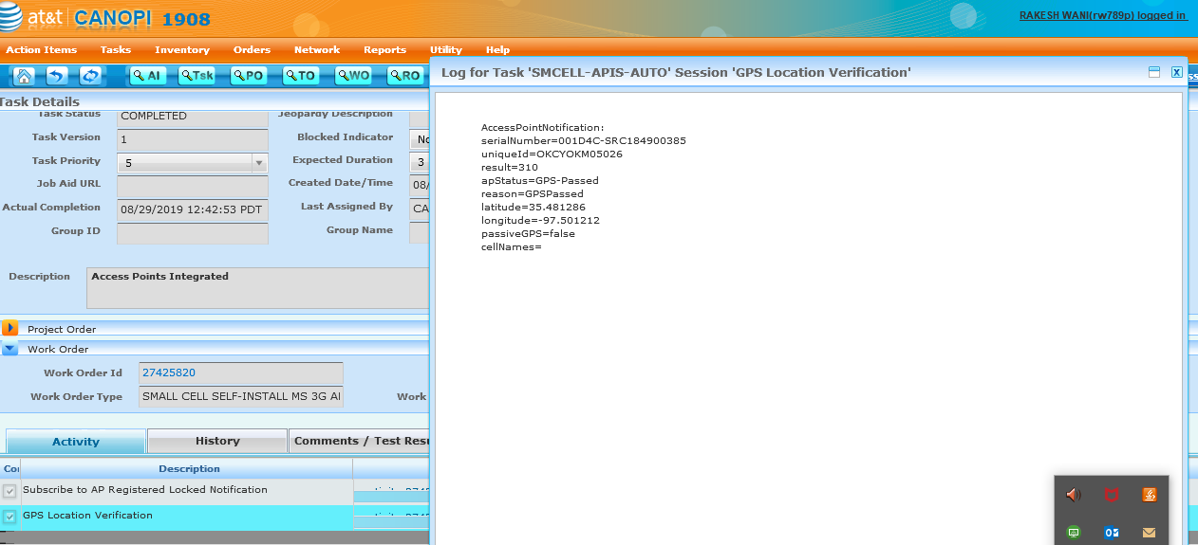

Check AMS Request got sent or not and if sent so what reason it is failed

To check AMS in mcell.log

grep -l 'LBALLUSRC184100135' mcell.log*

you get the result of mcell.log files, you need chek the ActivateMetrocellServiceRequest in mcell.log which you got from above command respective to the timestamp of GPS passed on GUI.

check the log for ActivateMetrocellServiceRequest in mcell.log if its failed put in soap with below WSDL

<https://csi-wa-int.it.att.com:38443/Services/com/cingular/csi/bpe/ActivateMetrocellService.jws>

Request XML:

<env:Envelope xmlns:env="<http://schemas.xmlsoap.org/soap/envelope/>">

  <env:Header>

    <mes:MessageHeader xmlns:mes="<http://csi.cingular.com/CSI/Namespaces/Types/Public/MessageHeader.xsd>">

      <mh:TrackingMessageHeader xmlns:mh="<http://csi.cingular.com/CSI/Namespaces/Types/Public/MessageHeader.xsd>">

        <cdm:version xmlns:cdm="<http://csi.cingular.com/CSI/Namespaces/Types/Public/CingularDataModel.xsd>">v128</cdm:version>

        <cdm:messageId xmlns:cdm="<http://csi.cingular.com/CSI/Namespaces/Types/Public/CingularDataModel.xsd>">3ee9d4f0-2a33-4794-9b11-654e71480d8d</cdm:messageId>

        <cdm:dateTimeStamp xmlns:cdm="<http://csi.cingular.com/CSI/Namespaces/Types/Public/CingularDataModel.xsd>">2019-02-22T20:24:12Z</cdm:dateTimeStamp>

    </mh:TrackingMessageHeader>

      <mh:SecurityMessageHeader xmlns:mh="<http://csi.cingular.com/CSI/Namespaces/Types/Public/MessageHeader.xsd>">

        <cdm:userName xmlns:cdm="<http://csi.cingular.com/CSI/Namespaces/Types/Public/CingularDataModel.xsd>">canopi</cdm:userName>

        <cdm:userPassword xmlns:cdm="<http://csi.cingular.com/CSI/Namespaces/Types/Public/CingularDataModel.xsd>">rvTxMkXH6kLn</cdm:userPassword>

    </mh:SecurityMessageHeader>

      <mh:SequenceMessageHeader xmlns:mh="<http://csi.cingular.com/CSI/Namespaces/Types/Public/MessageHeader.xsd>">

        <cdm:sequenceNumber xmlns:cdm="<http://csi.cingular.com/CSI/Namespaces/Types/Public/CingularDataModel.xsd>">1</cdm:sequenceNumber>

        <cdm:totalInSequence xmlns:cdm="<http://csi.cingular.com/CSI/Namespaces/Types/Public/CingularDataModel.xsd>">1</cdm:totalInSequence>

    </mh:SequenceMessageHeader>

    </mes:MessageHeader>

  </env:Header>

  <env:Body>

       <ns0:ActivateMetrocellServiceRequest xmlns:ns0="<http://csi.cingular.com/CSI/Namespaces/Container/Public/ActivateMetrocellServiceRequest.xsd>" xmlns:ns6="<http://csi.cingular.com/CSI/Namespaces/Types/Public/CingularDataModel.xsd>">

      <ns0:equipmentIdentifier>LBALLUSRC184900043</ns0:equipmentIdentifier>

      <ns0:cellGlobalIdentity>3104106450208076</ns0:cellGlobalIdentity>

      <ns0:GPSGeocode>

        <ns6:latitude>41.864089</ns6:latitude>

        <ns6:longitude>-88.266098</ns6:longitude>

      </ns0:GPSGeocode>

      <ns0:eCellularGlobalId>31041041fcf88d8f4</ns0:eCellularGlobalId>

    </ns0:ActivateMetrocellServiceRequest>

  </env:Body>

</env:Envelope>

Once you get success, check Activate AP response in mcell.log

Once its success and LTE got radio enabled send Notify request. By below WSDL and XML

Notify : [https://csi-wa-int.it.att.com:38443/Services/com/cingular/csi/bpe/NotifyMetrocellAction.jws](https://ind01.safelinks.protection.outlook.com/?url=https%3A%2F%2Fcsi-wa-int.it.att.com%3A38443%2FServices%2Fcom%2Fcingular%2Fcsi%2Fbpe%2FNotifyMetrocellAction.jws&data=02%7C01%7Crw00372829%40techmahindra.com%7Cbb0b7754bada437ab4e608d72d7b98f9%7Cedf442f5b9944c86a131b42b03a16c95%7C0%7C0%7C637027881176339975&sdata=1VZcc3DroQCel%2FNACeiB2w%2BCtC%2F7XKVlcF2nnws8NP0%3D&reserved=0)

<env:Envelope xmlns:env="<http://schemas.xmlsoap.org/soap/envelope/>">

  <env:Header>

    <mes:MessageHeader xmlns:mes="<http://csi.cingular.com/CSI/Namespaces/Types/Public/MessageHeader.xsd>">

      <mh:TrackingMessageHeader xmlns:mh="<http://csi.cingular.com/CSI/Namespaces/Types/Public/MessageHeader.xsd>">

        <cdm:dateTimeStamp xmlns:cdm="<http://csi.cingular.com/CSI/Namespaces/Types/Public/CingularDataModel.xsd>">2016-06-23T16:09:21Z</cdm:dateTimeStamp>

        <cdm:version xmlns:cdm="<http://csi.cingular.com/CSI/Namespaces/Types/Public/CingularDataModel.xsd>">v104</cdm:version>

    </mh:TrackingMessageHeader>

      <mh:SecurityMessageHeader xmlns:mh="<http://csi.cingular.com/CSI/Namespaces/Types/Public/MessageHeader.xsd>">

        <cdm:userName xmlns:cdm="<http://csi.cingular.com/CSI/Namespaces/Types/Public/CingularDataModel.xsd>">canopi</cdm:userName>

        <cdm:userPassword xmlns:cdm="<http://csi.cingular.com/CSI/Namespaces/Types/Public/CingularDataModel.xsd>">rvTxMkXH6kLn</cdm:userPassword>

    </mh:SecurityMessageHeader>

      <mh:SequenceMessageHeader xmlns:mh="<http://csi.cingular.com/CSI/Namespaces/Types/Public/MessageHeader.xsd>">

        <cdm:sequenceNumber xmlns:cdm="<http://csi.cingular.com/CSI/Namespaces/Types/Public/CingularDataModel.xsd>">1</cdm:sequenceNumber>

        <cdm:totalInSequence xmlns:cdm="<http://csi.cingular.com/CSI/Namespaces/Types/Public/CingularDataModel.xsd>">1</cdm:totalInSequence>

    </mh:SequenceMessageHeader>

    </mes:MessageHeader>

  </env:Header>

  <env:Body>

    <ns2:NotifyMetrocellActionRequest xmlns:ns2="<http://csi.cingular.com/CSI/Namespaces/Container/Public/NotifyMetrocellActionRequest.xsd>" xmlns:ns6="<http://csi.cingular.com/CSI/Namespaces/Types/Public/CingularDataModel.xsd>">

      <ns2:action>002</ns2:action>

      <ns2:radioBaseStationId>731192</ns2:radioBaseStationId>

      <ns2:Equipment>

        <ns2:equipmentIdentifier>LBALLUSRC184900385</ns2:equipmentIdentifier>

        <ns2:Response>

          <ns6:code>0</ns6:code>

          <ns6:description>APActivated</ns6:description>

        </ns2:Response>

      </ns2:Equipment>

      <ns2:Response>

        <ns6:code>0</ns6:code>

        <ns6:description>SUCCESS</ns6:description>

      </ns2:Response>

    </ns2:NotifyMetrocellActionRequest>

  </env:Body>

</env:Envelope>

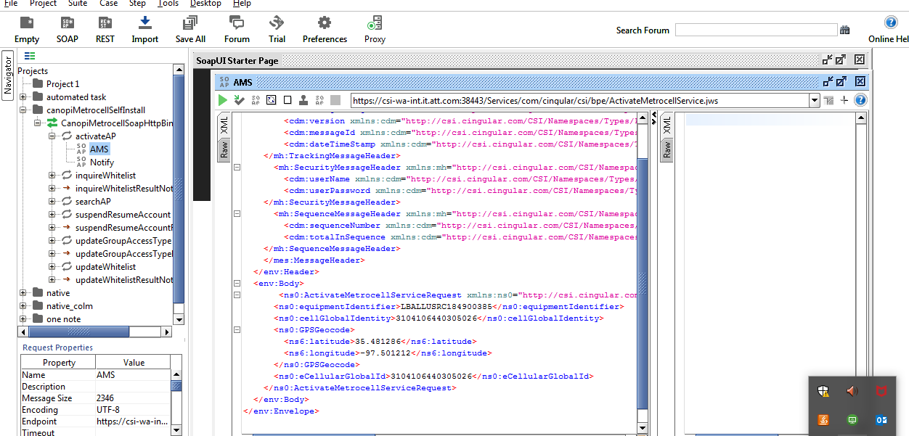

Once you get success check the status of Activate AP Request in mcell.log

i.e in latest log mcell.log

if it success then send the Notify Request by checking the LTE WO

it should pass the enable radio sub task then send Notify request Manually from Soap

Notify Request

<env:Envelope xmlns:env="http://schemas.xmlsoap.org/soap/envelope/">

<env:Header>

<mes:MessageHeader xmlns:mes="http://csi.cingular.com/CSI/Namespaces/Types/Public/MessageHeader.xsd">

<mh:TrackingMessageHeader xmlns:mh="http://csi.cingular.com/CSI/Namespaces/Types/Public/MessageHeader.xsd">

<cdm:dateTimeStamp xmlns:cdm="http://csi.cingular.com/CSI/Namespaces/Types/Public/CingularDataModel.xsd">2016-06-23T16:09:21Z</cdm:dateTimeStamp>

<cdm:version xmlns:cdm="http://csi.cingular.com/CSI/Namespaces/Types/Public/CingularDataModel.xsd">v104</cdm:version>

</mh:TrackingMessageHeader>

<mh:SecurityMessageHeader xmlns:mh="http://csi.cingular.com/CSI/Namespaces/Types/Public/MessageHeader.xsd">

<cdm:userName xmlns:cdm="http://csi.cingular.com/CSI/Namespaces/Types/Public/CingularDataModel.xsd">canopi</cdm:userName>

<cdm:userPassword xmlns:cdm="http://csi.cingular.com/CSI/Namespaces/Types/Public/CingularDataModel.xsd">rvTxMkXH6kLn</cdm:userPassword>

</mh:SecurityMessageHeader>

<mh:SequenceMessageHeader xmlns:mh="http://csi.cingular.com/CSI/Namespaces/Types/Public/MessageHeader.xsd">

<cdm:sequenceNumber xmlns:cdm="http://csi.cingular.com/CSI/Namespaces/Types/Public/CingularDataModel.xsd">1</cdm:sequenceNumber>

<cdm:totalInSequence xmlns:cdm="http://csi.cingular.com/CSI/Namespaces/Types/Public/CingularDataModel.xsd">1</cdm:totalInSequence>

</mh:SequenceMessageHeader>

</mes:MessageHeader>

</env:Header>

<env:Body>

<ns2:NotifyMetrocellActionRequest xmlns:ns2="http://csi.cingular.com/CSI/Namespaces/Container/Public/NotifyMetrocellActionRequest.xsd" xmlns:ns6="http://csi.cingular.com/CSI/Namespaces/Types/Public/CingularDataModel.xsd">

<ns2:action>002</ns2:action>

<ns2:radioBaseStationId>564116</ns2:radioBaseStationId>

<ns2:Equipment>

<ns2:equipmentIdentifier>1214410876</ns2:equipmentIdentifier>

<ns2:Response>

<ns6:code>0</ns6:code>

<ns6:description>APActivated</ns6:description>

</ns2:Response>

</ns2:Equipment>

<ns2:Response>

<ns6:code>0</ns6:code>

<ns6:description>SUCCESS</ns6:description>

</ns2:Response>

</ns2:NotifyMetrocellActionRequest>

</env:Body>

</env:Envelope>

# Ticket Closure Process

1. Problem_ticket = AMS/Notify Request
2. Resolution_Text = Internal System Issue
3. Handover_Text = Under analysis
4. Key_item_Effected = Mobility_Others
5. Sev_Class = Mobility CANOPI
6. Big_Board_Flag = Green
7. Event_type = Baseline
8. Event = X
9. Start time needs current date
10. Eend time need current date
11. MTTR Description = AMS/Notify Request
12. Question Template

Template Name:RCA-P&A-BOA  
Question Text:A) Brief description of the issue (your understanding based on the investigation you performed)  
Answer Text:Request of AMS / Notify  
Question Text:B) What action did you take to resolve the issue?  
Answer Text:AMS/Notify sent Manually  
Question Text:C) Which application provided the workaround?  
Answer Text:Mobility Canopi  
Question Text:D) If this is a user process issue, what incorrect steps were taken?  
Answer Text:na  
Question Text:E) Is the error message clear and guide users or support teams toward the solution?  
Answer Text:na  
Question Text:F) What could be done by your system or the interfacing systems to prevent in the future?  
Answer Text:na  
Question Text:G) What application do you think should start the Root Cause process?  
Answer Text:na  
Question Text:H) Did you attach log files/XMLs/screen shots to the ticket logs?  
Answer Text:na  
Question Text:I) What is the Root Cause (if known)?  
Answer Text:EID Activated in SMP but not sync with Canopi